**Experiment -1.1**

Install Git and create a repository.

**Student Name:Km Ayushi UID:22BDO10055**

**Branch: CSE(DevOps) Section/Group-22BCD-1(B)**

**Semester: 4th Date of Performance:13/01/24**

**Subject Name- Git and GitHub Subject Code:22CSH-293**

**1. Aim/Overview of the practical:** Install Git and create the repository.

**2. Task to be done:** Installing Git launching it and creating a repository.

**3. Theme/Interests definition( For creative domains):**

Git is a DevOps tool used for source code management. It is a free and open-source version control system that handles small to huge projects efficiently. Git is used to track changes in the source code, enabling multiple developers to work together on non-linear development.

**4. Steps for experiment/practical:**

1. Browse to the official Git website: <https://git-scm.com/downloads>.

2. Click the download link for Windows and allow the download to complete.

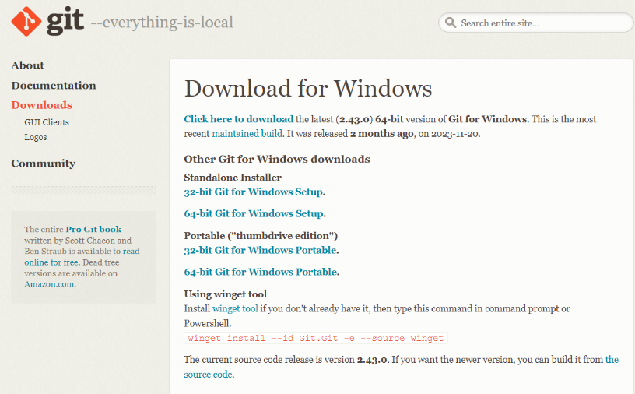

3.  Browse to the download location. Double-click the file to extract and launch the installer. Allow the app to make changes by clicking on Yes to launch the installer.

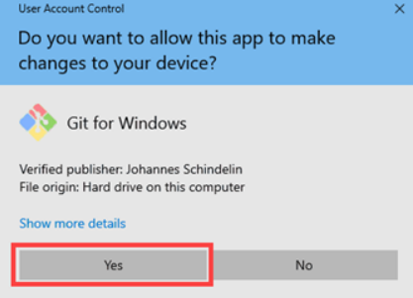

4. Review the GNU General Public License and click Next.

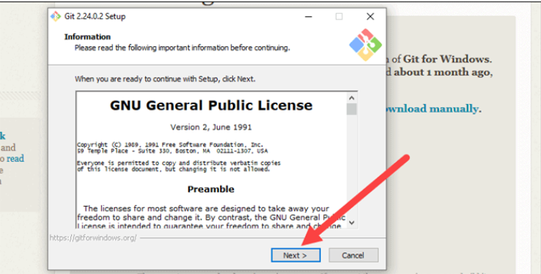

5. Confirm the location for installation, click Next.

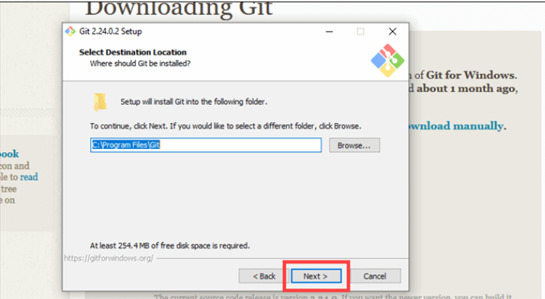

6. Create a start menu folder. Select a text editor you’d like to use with Git and click Next.

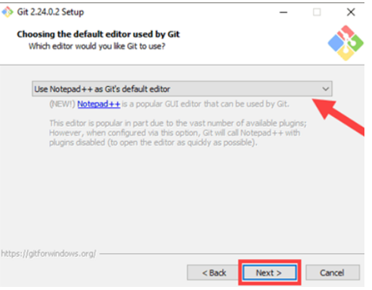

7. The next step allows you to choose a different name for your initial branch, leave the default option and click Next.

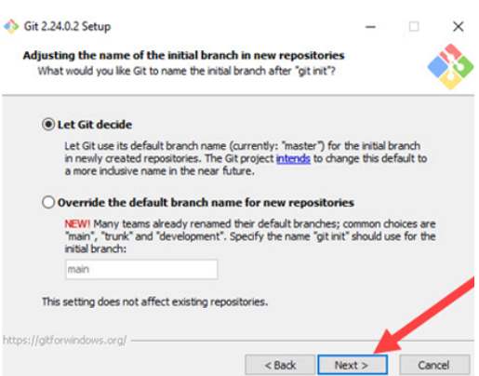

8. This installation step allows you to change the PATH environment. Leave this in the middle selection and click Next.

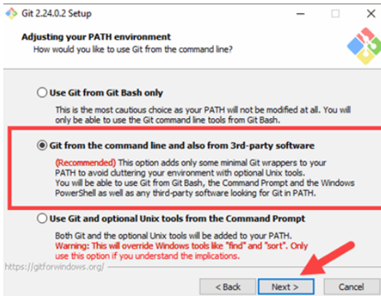

9. The installer now asks which SSH client you want Git to use if no changes are there click on next.

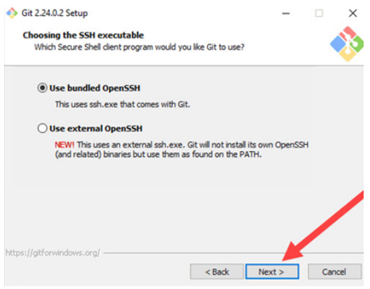

10. If you’re working in an Active Directory environment, you may need to switch to Windows Store certificates. Click **Next**.

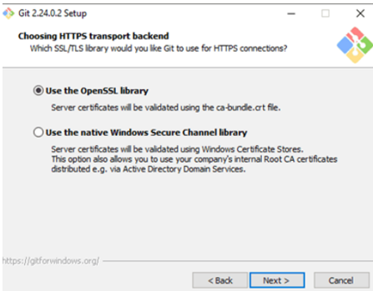

11. Choose the [terminal emulator](https://phoenixnap.com/glossary/terminal-emulation) you want to use. The default MinTTY is recommended, for its features. Click **Next**.

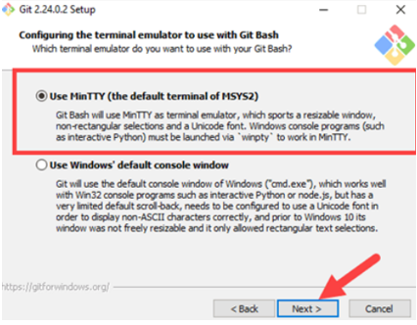

12.  The installer now asks what the **git pull** command should do. Click **Next**to continue with the installation.

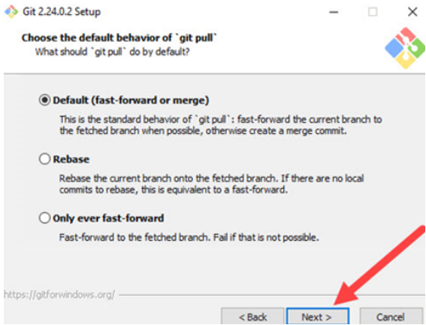

13. Next you should choose which credential helper to use. Leave the default option and click Next.

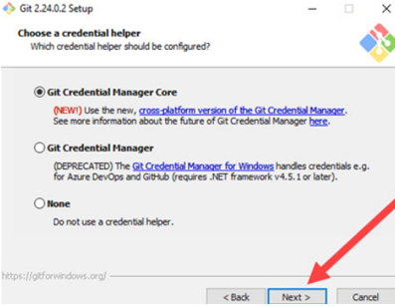

14. Once the installation is complete, tick the boxes to view the Release Notes or Launch Git Bash, then click **Finish**.

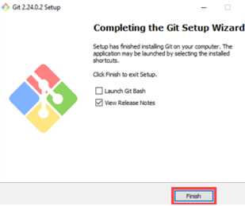

**Launch Git Bash Shell**

To launch **Git Bash** open the **Windows Start** menu, type ***git bash*** and press **Enter** (or click the application icon)-

To open Git Bash, type "git bash" in the Windows Start menu and click Enter.

**Creating a Repository on GitHub.**

1. After successful login into your account. Click on the option (+) to add a new repository to your account.

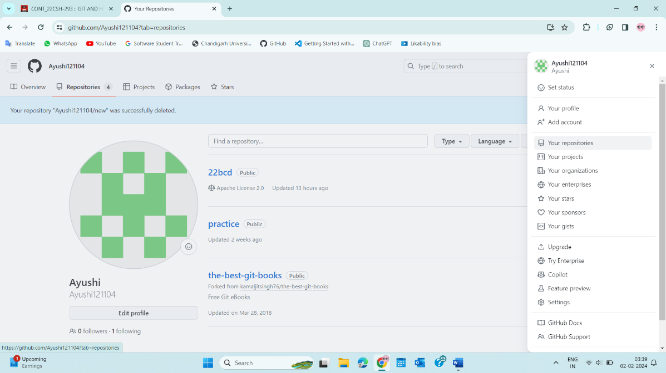

1. After creating a new repository, we need to initialize it by naming the project, choosing visibility, and then clicking the Create Repository button.

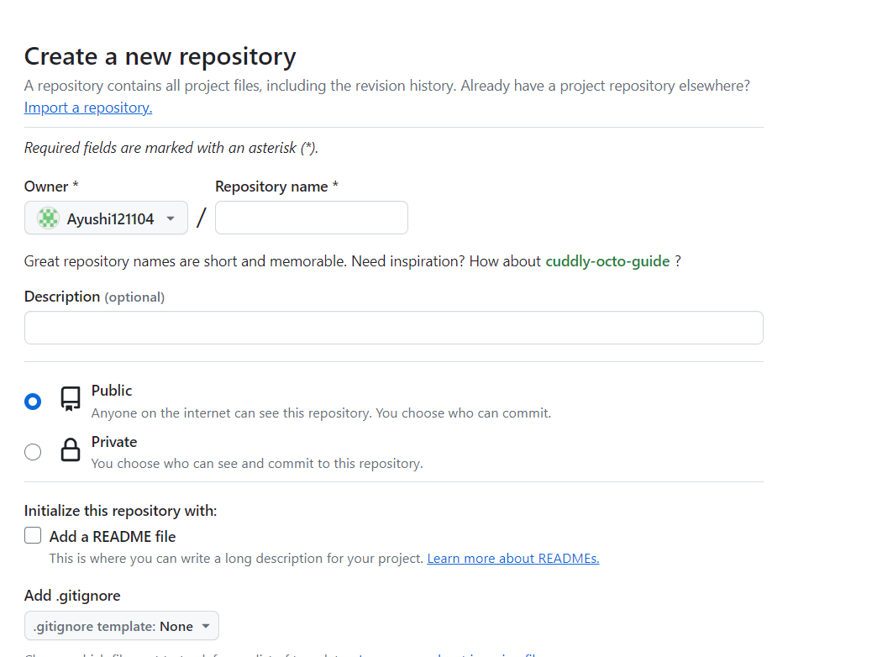

1. Once you click on the button, you will be redirected to the page below. Currently, we only possess a readme file.

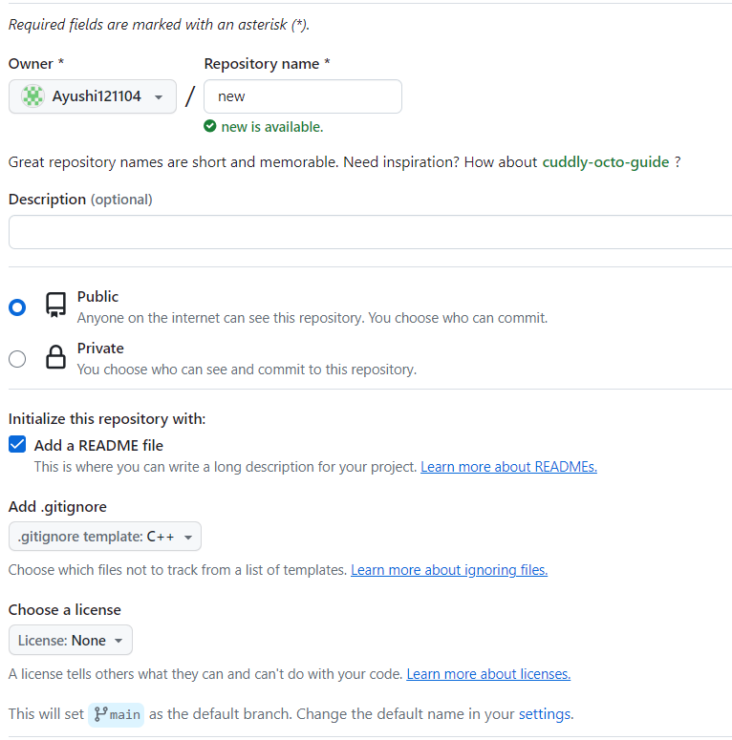

4 Click on the "Upload files" button and follow the necessary steps to upload files to Git Hub. Once completed, all files will be visible.

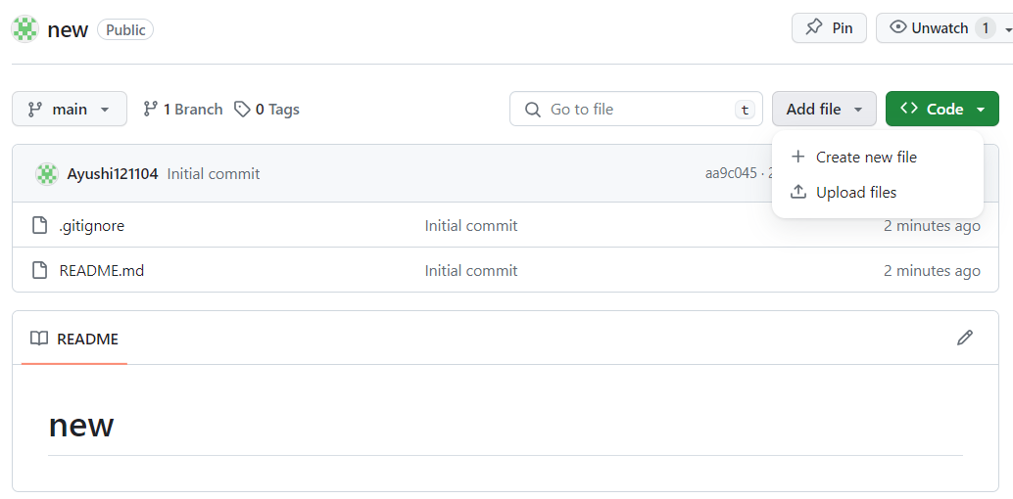

**Configure GitHub Credentials**

To use your GitHub credentials with your local Git installation, you must enter the following configuration.

git config --global user.name "Ayushi"

git config --global user.email “[22BDO10055@cuchd.in](mailto:22BDO10055@cuchd.in)”

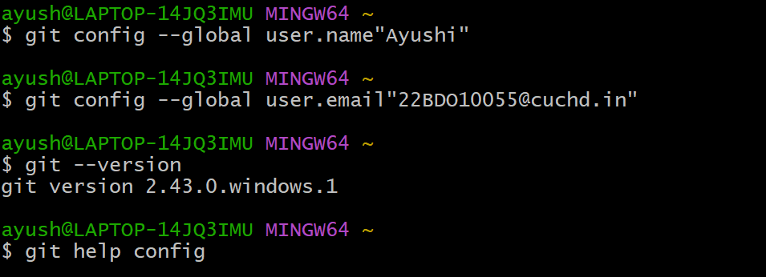

**Clone a GitHub Repository**

Go to the current repository on GitHub. In the top right above the list of files, open the **Clone or Download** drop-down menu. Copy the **URL for cloning over HTTPS**.

And put it in the git bash command:

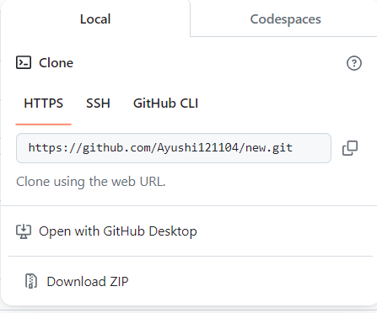

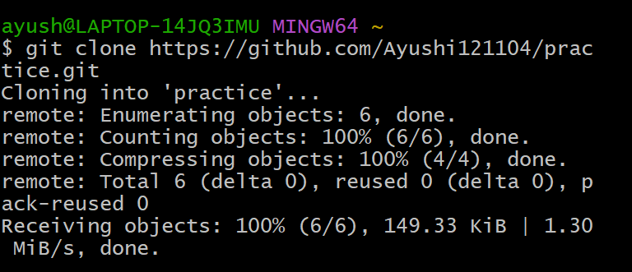

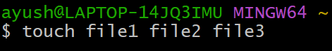

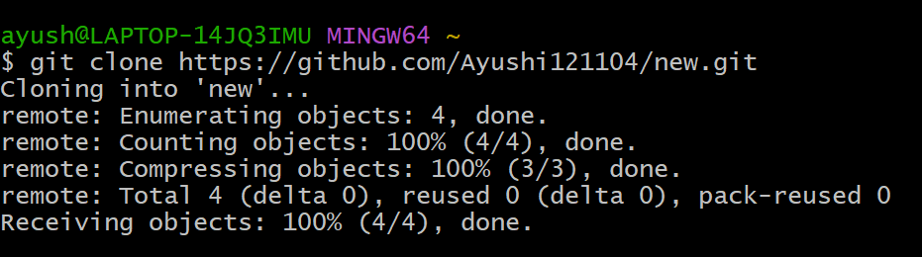

**5. Result/Output/Writing Summary:**

We have successfully installed Git and created a GitHub account. We have also created a repository and executed various commands on it.

**Learning outcomes (What I have learnt):**

**1.** I have about Git and GitHub.

**2.** I have learnt about creating repositories.

**3.** learnt about some git commands.

**4.** I have learnt about how to clone two repositories.

**5.** I have learnt about fork, pull and push requests.

**Evaluation Grid (To be created as per the SOP and Assessment guidelines by the faculty):**

|  |  |  |  |
| --- | --- | --- | --- |
| Sr. No. | Parameters | Marks Obtained | Maximum Marks |
| 1. |  |  |  |
| 2. |  |  |  |
| 3. |  |  |  |
|  |  |  |  |